**Problem set 2**

1. (Total: 20 points) We want to use logistic regression to predict the probability of default using income, balance, and student on the Default data set. Our goal is to estimate the test error of this logistic regression model using the validation set approach. Do not forget to set a random seed before beginning your analysis.

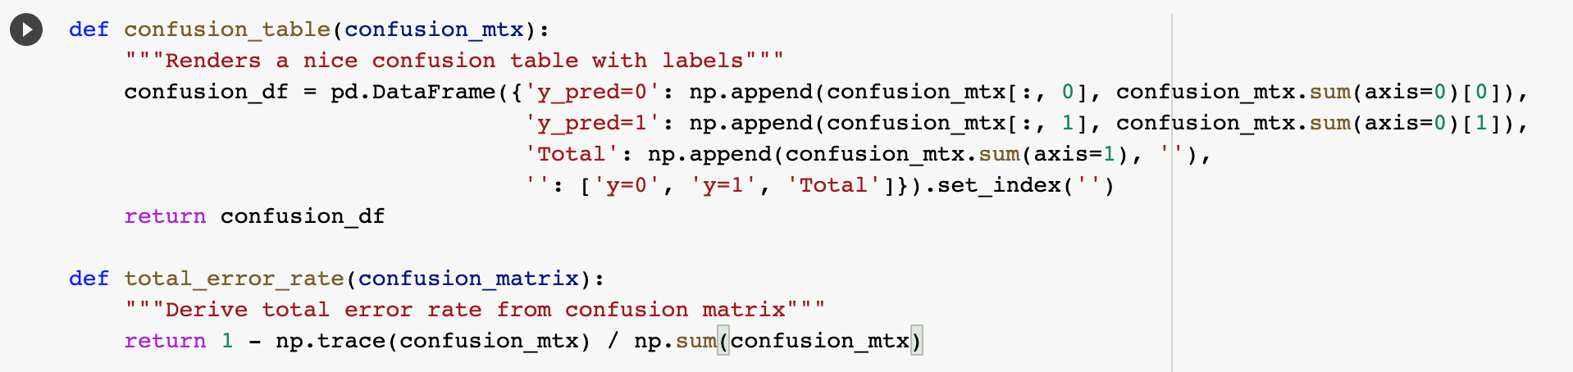

1. (5 points) Using the validation set approach, estimate the test error of a logistic regression model that uses income and balance to predict default. In order to do this, you must perform the following steps:  
   1. Split the sample set into a training set and a validation set.  
   2. Fit a multiple logistic regression model using only the training observations.  
   3. Obtain a prediction of default status for each individual in the validation set by computing the posterior probability of default for that individual, and classifying the individual to the default category if the posterior probability is greater than 0.5.  
   4. Compute the validation set error, which is the fraction of the observations in the validation set that are misclassified.

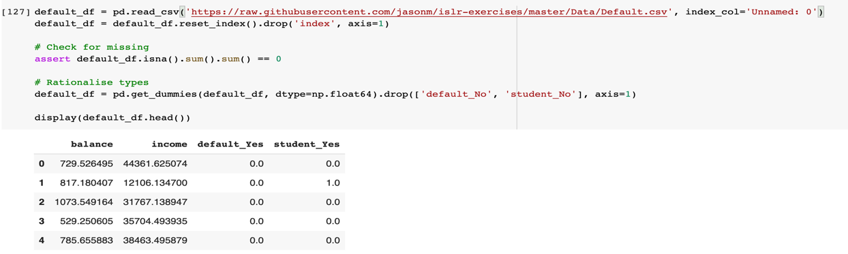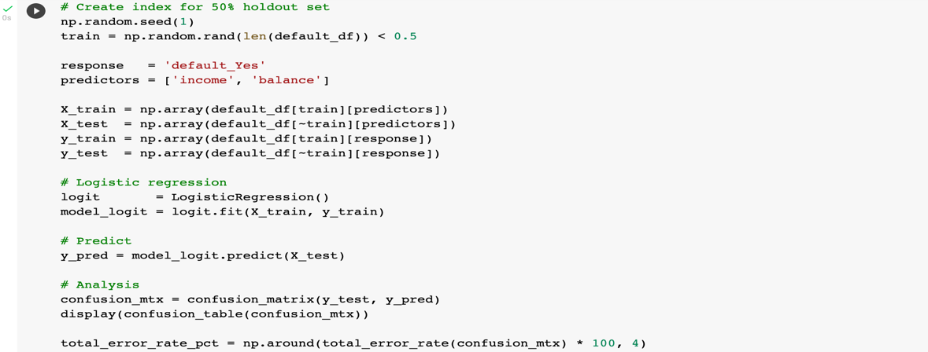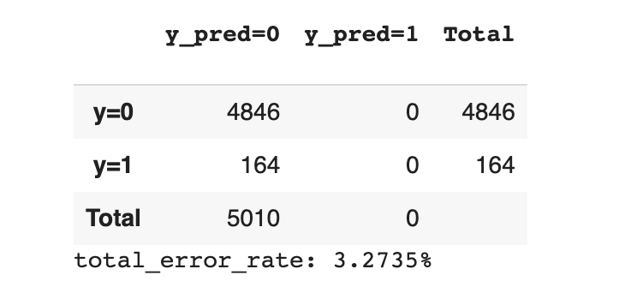

1. Repeat the process in (a) three times, using three different splits of the observations into a training set and a validation set. Describe your findings and comment on the results obtained.

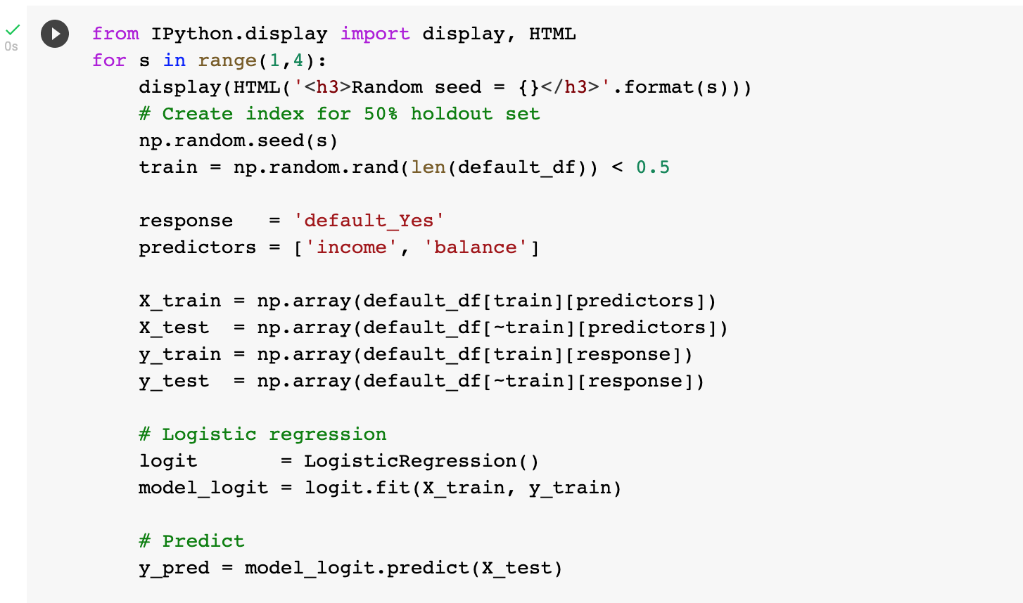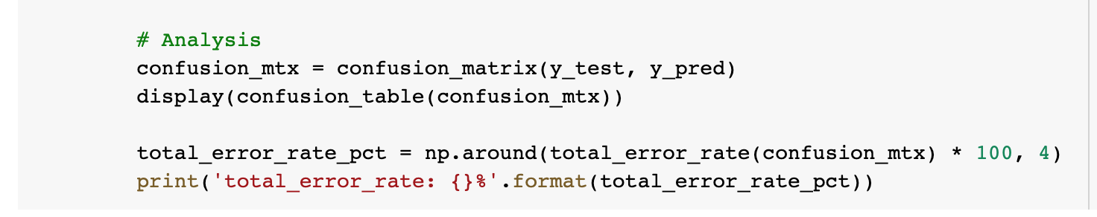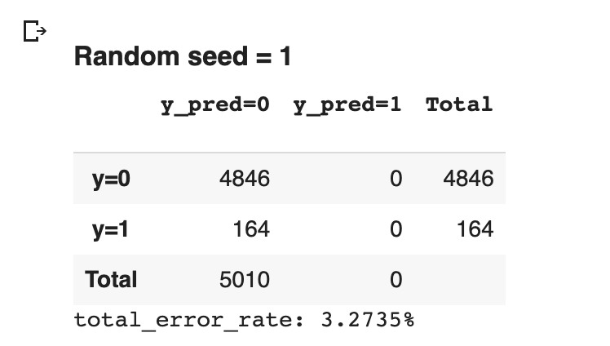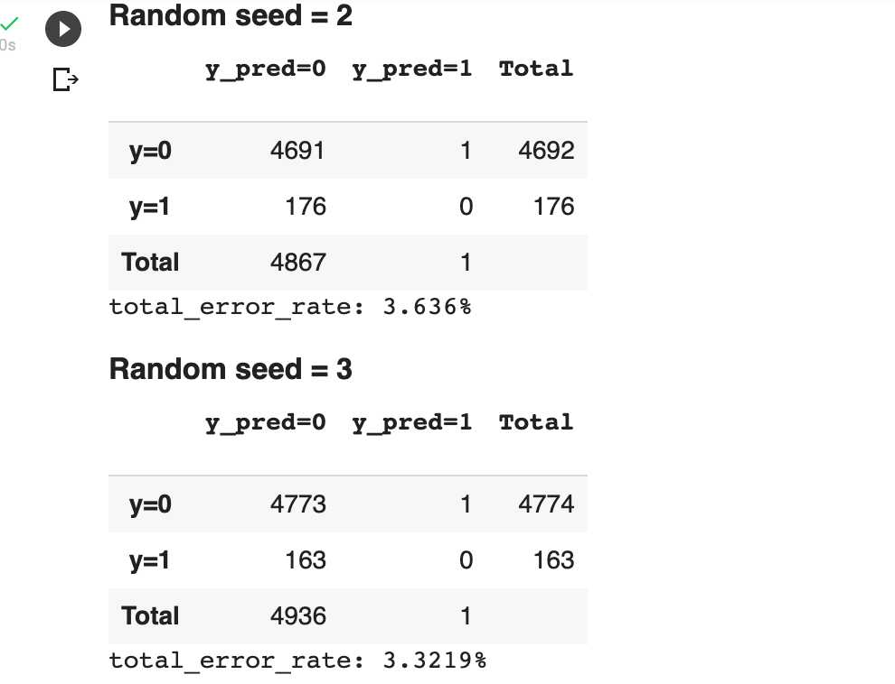

1. Now consider a logistic regression model that predicts the probability of default using income, balance, and a dummy variable for student. Estimate the test error for this model using the validation set approach. Comment on whether or not including a dummy variable for student leads to a reduction in the test error rate.

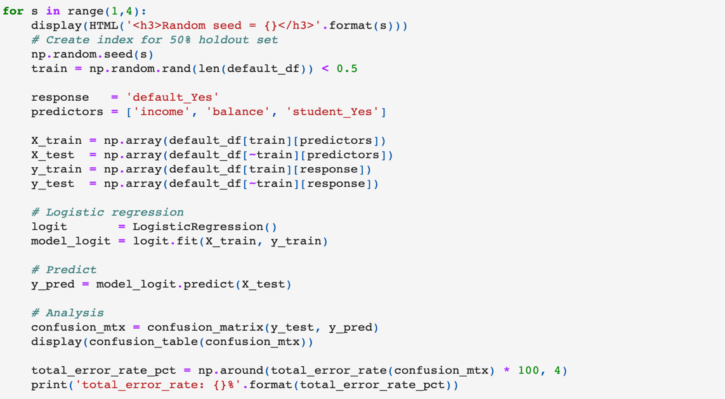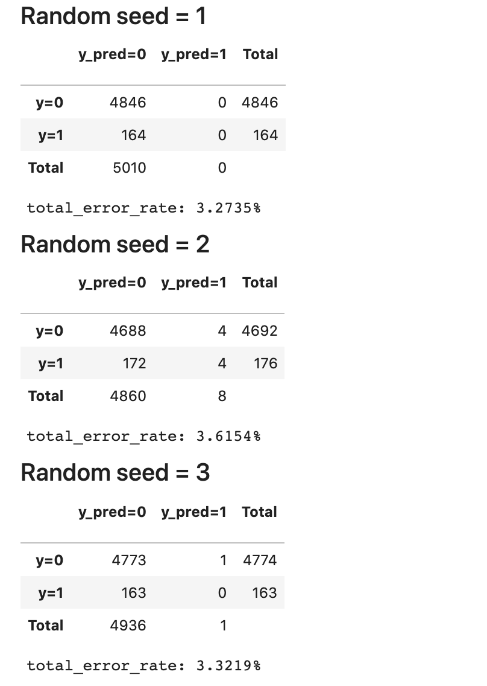

It is difficult to discern if the student predictor has improved the model because of the variation in results.

1. Suppose we collect data for a group of bank customers with variables

• default A variable with levels No and Yes indicating whether the customer defaulted on their debt  
• student A variable with levels No and Yes indicating whether the customer is a student  
• balance The average balance that the customer has remaining on their credit card after making their monthly payment  
• income of a customer  
We fit a logistic regression and produce estimated coefficient, ˆβ0 = −15.05, ˆβstudentYes = -0.5149,ˆβbalance = 0.003738, ˆβincome = −0.00000791.  
(a) Estimate the probability that a student with a balance of $3,000 and income $70,000 does default on a loan.

(b) Estimate the probability that borrower a balance of $3,000 and income $70,000  
who is not a student does default on a loan.

(c)How much income would the student in part (a) need to make to have a 90%  
chance of getting approved for a loan?

1. How much income would the borrower in part (b) need to make to have a 90% chance of getting approved for a loan?
2. This problem involves the Boston data set, which can be found in the file  
   Boston.csv. This data set contains the following columns:  
   crim per capita crime rate by town.  
   zn proportion of residential land zoned for lots over 25,000 sq.ft.  
   indus proportion of non-retail business acres per town.  
   chas Charles River dummy variable (= 1 if tract bounds river; 0 otherwise).  
   nox nitrogen oxides concentration (parts per 10 million).  
   rm average number of rooms per dwelling.  
   age proportion of owner-occupied units built prior to 1940.  
   dis weighted mean of distances to five Boston employment centres.  
   rad index of accessibility to radial highways.  
   tax full-value property-tax rate per $10,000.  
   ptratio pupil-teacher ratio by town.

black 1000(Bk −0.63)2 where Bk is the proportion of blacks by town.  
lstat lower status of the population (percent).  
medv median value of owner-occupied homes in $1,000s.  
We want to predict whether a given suburb has a crime rate above or below the median using the other variables in this data set.

1. For each predictor, fit a simple logistic regression model to predict the response. In which of the models is there a statistically significant association between the predictor and the response (set α = 0.05)

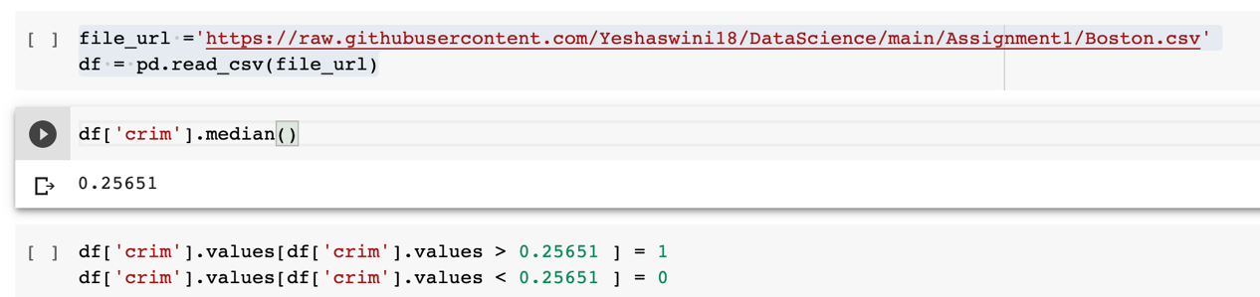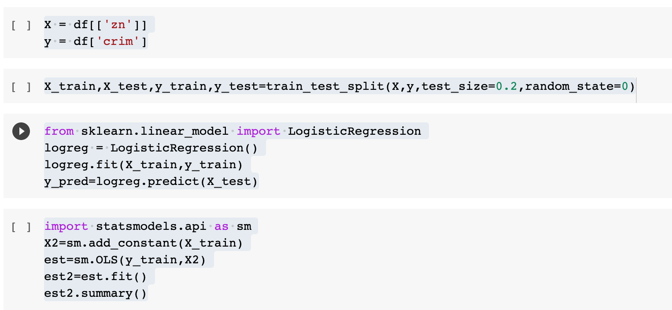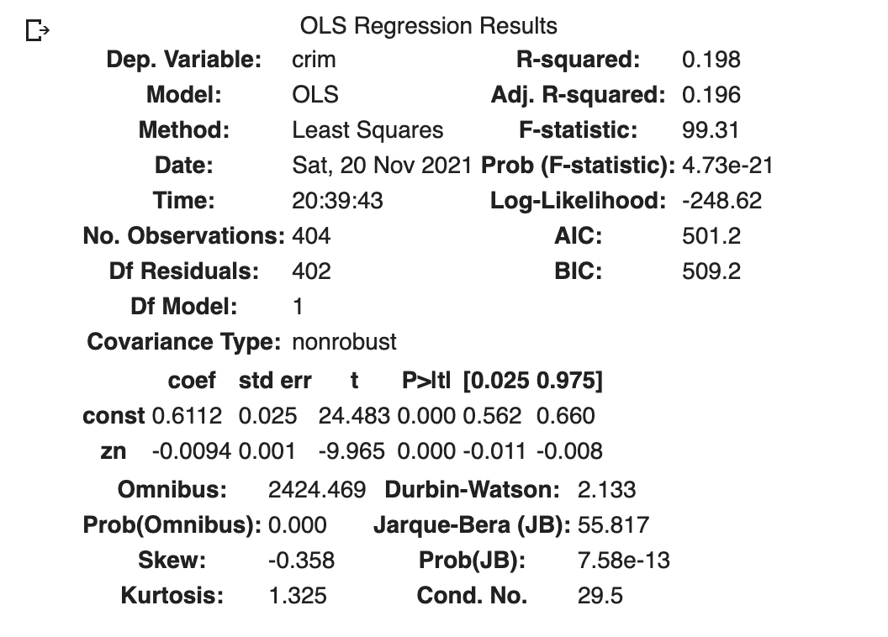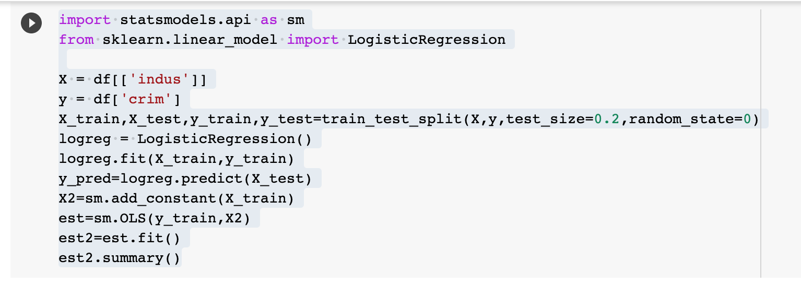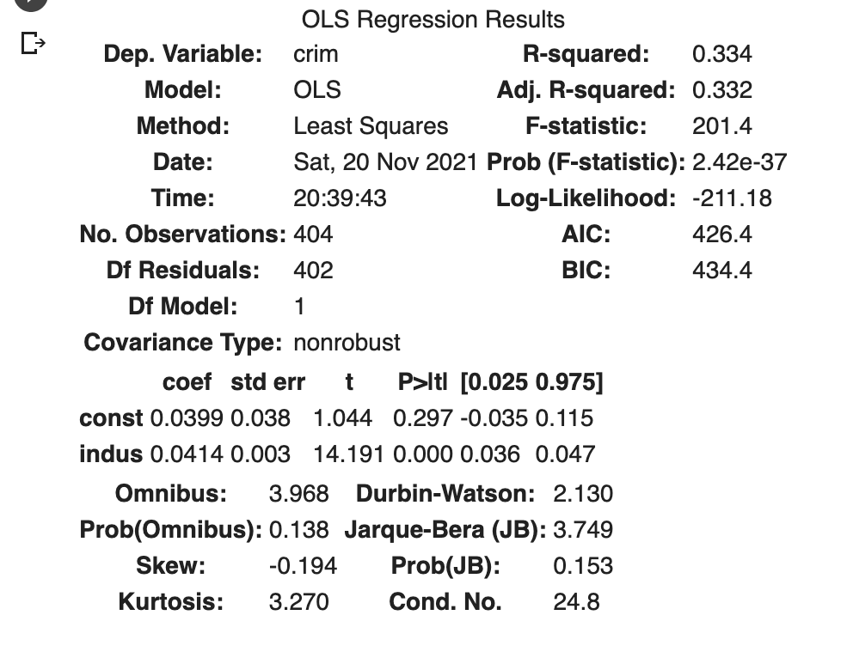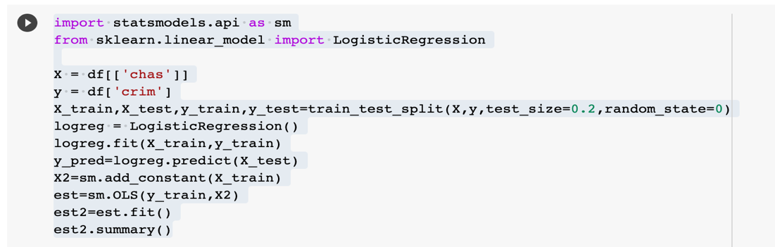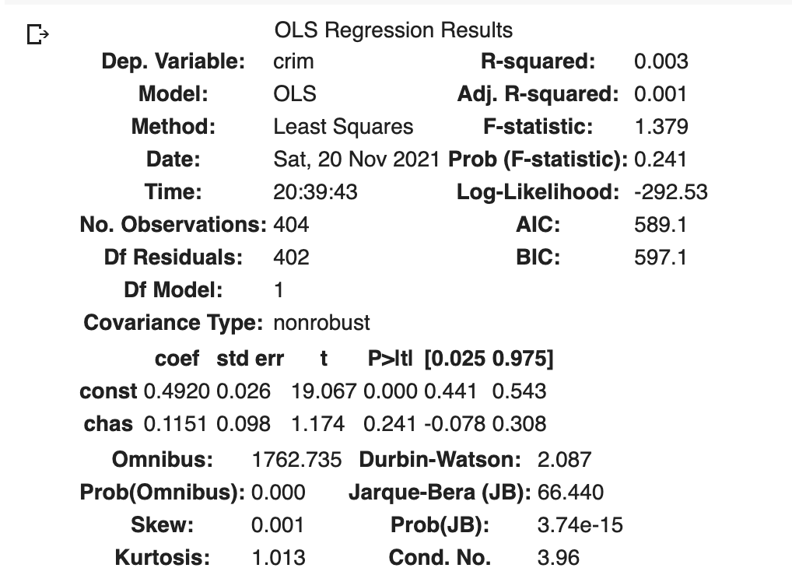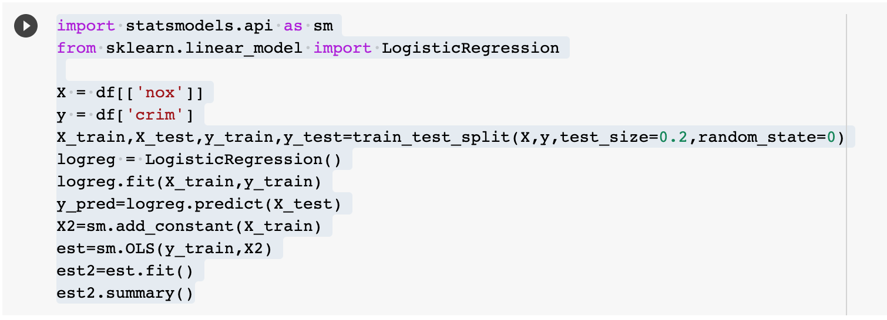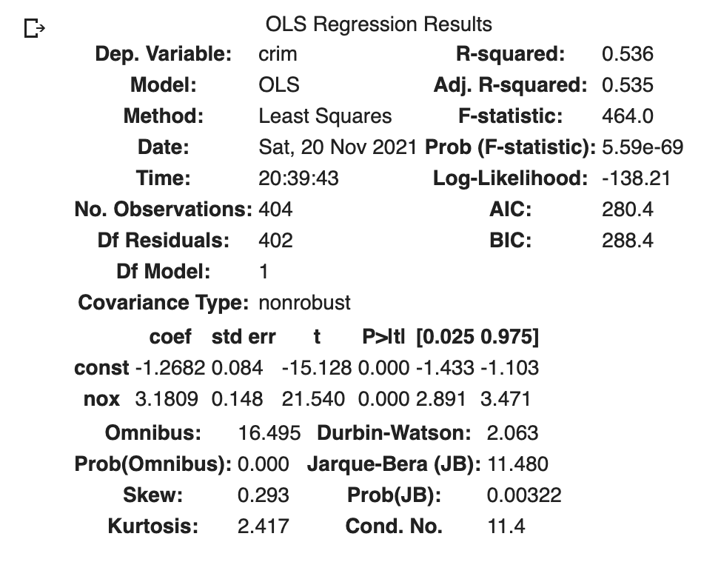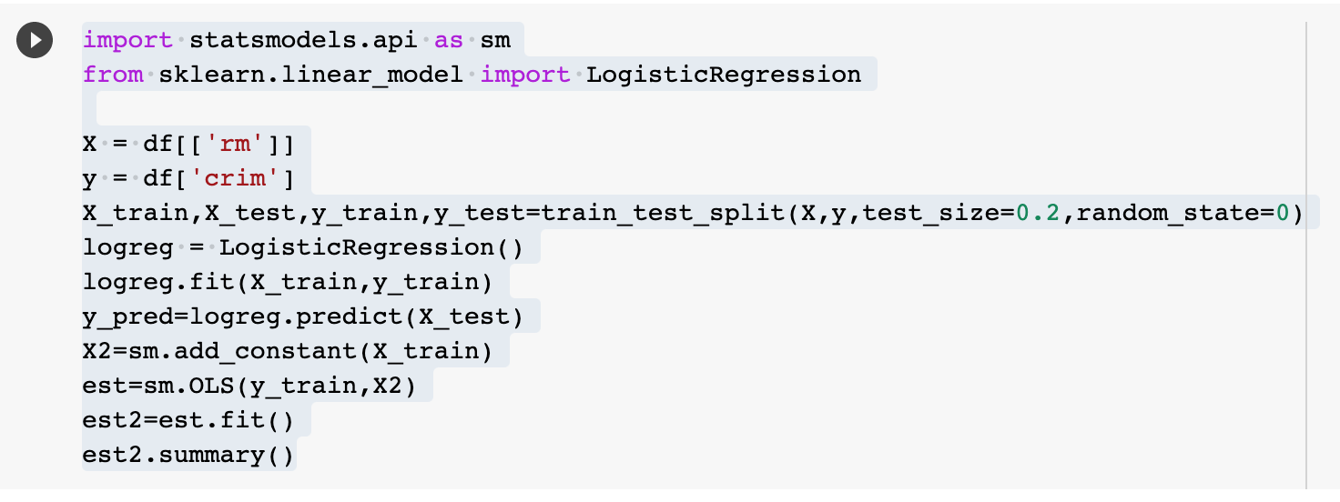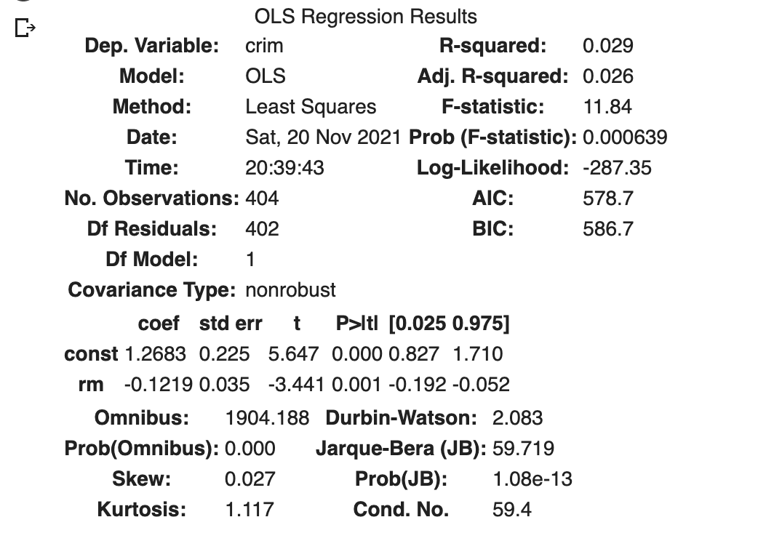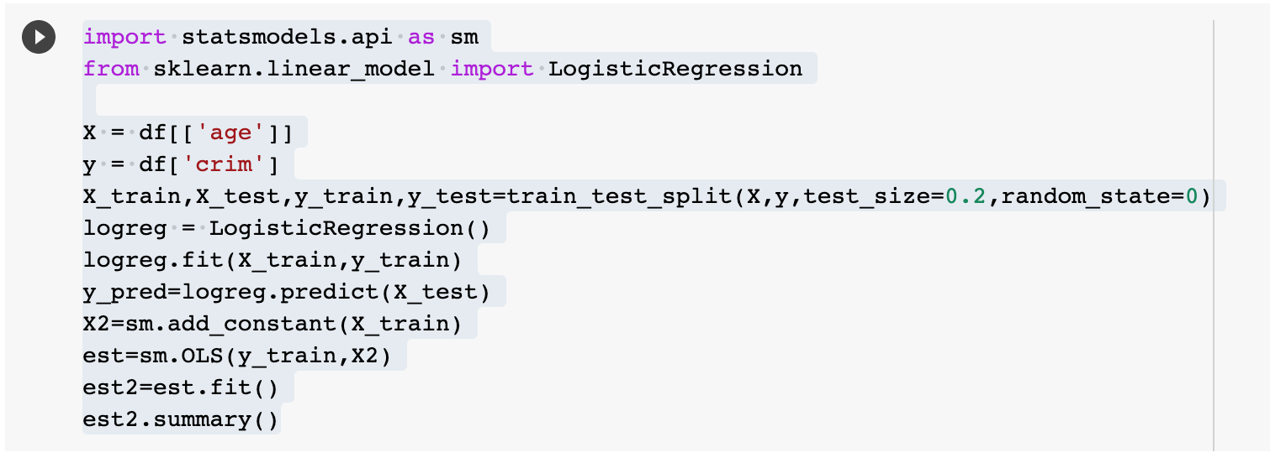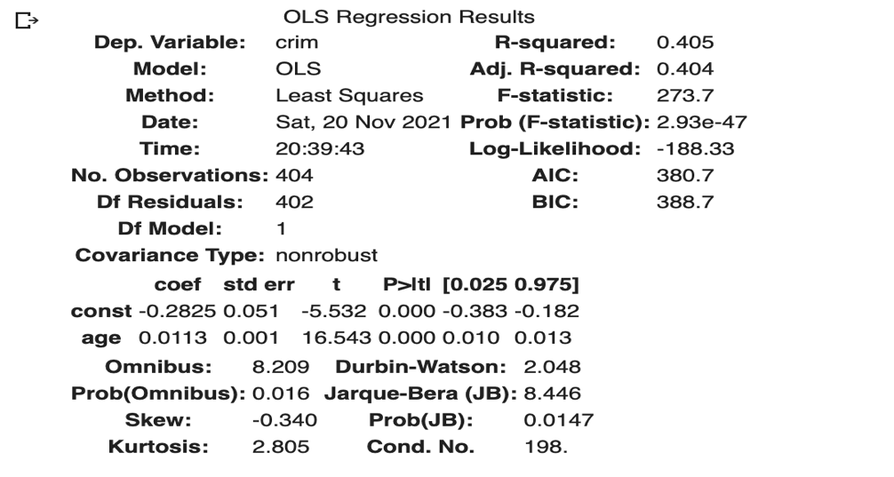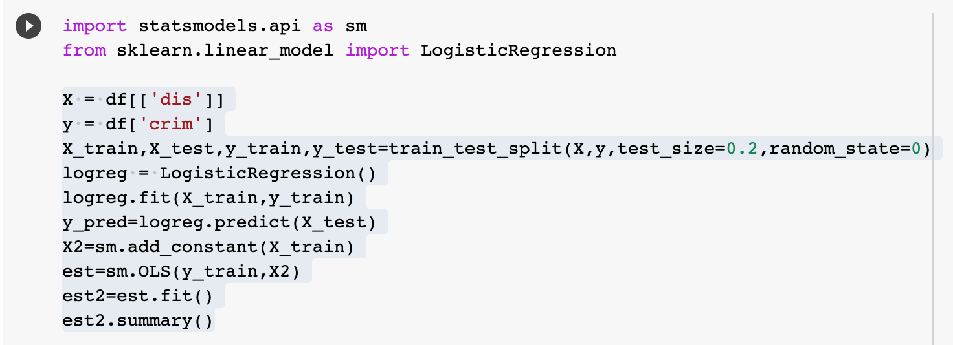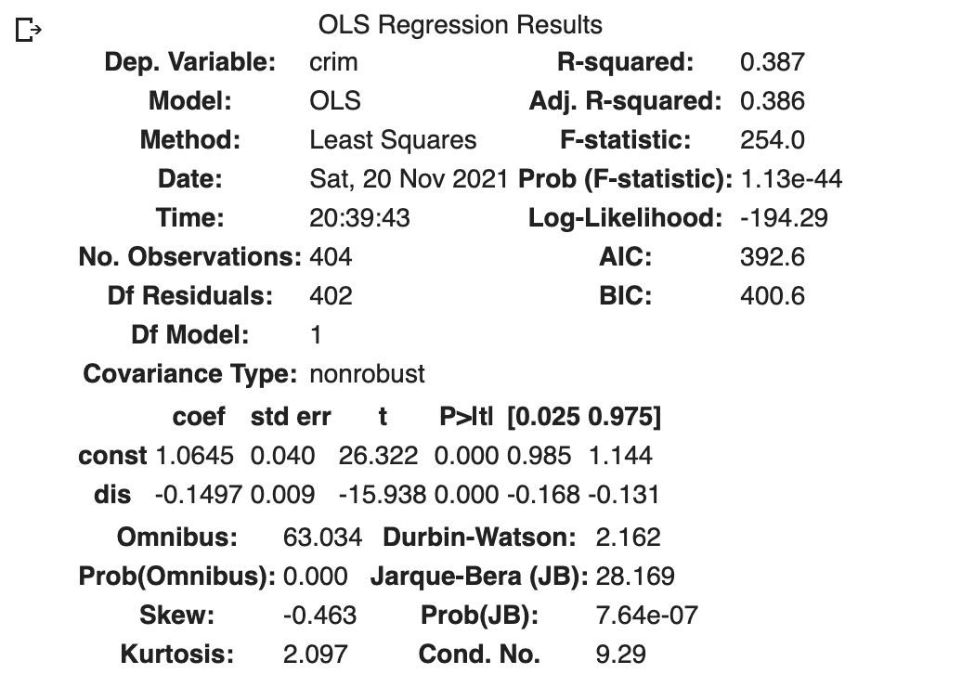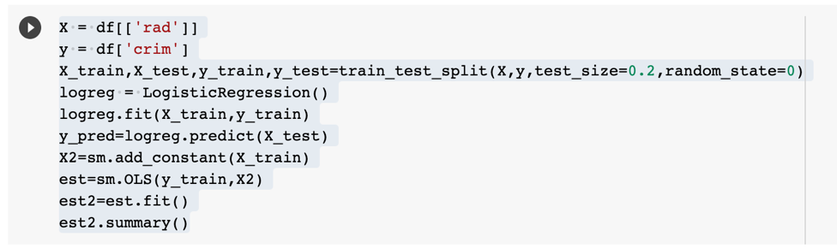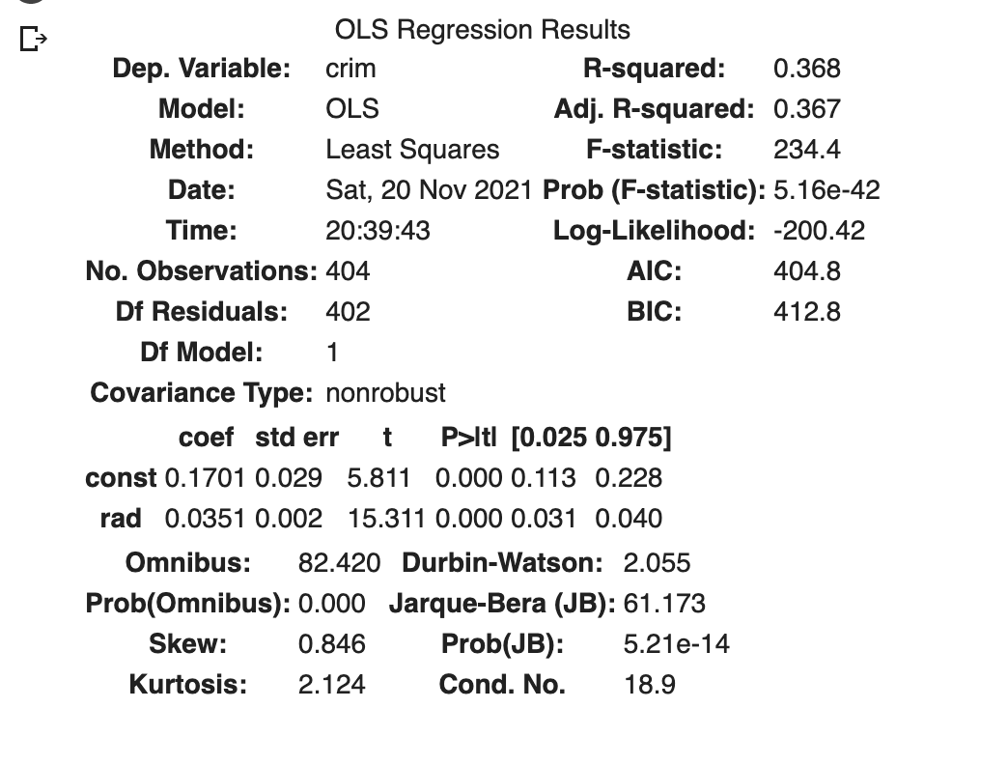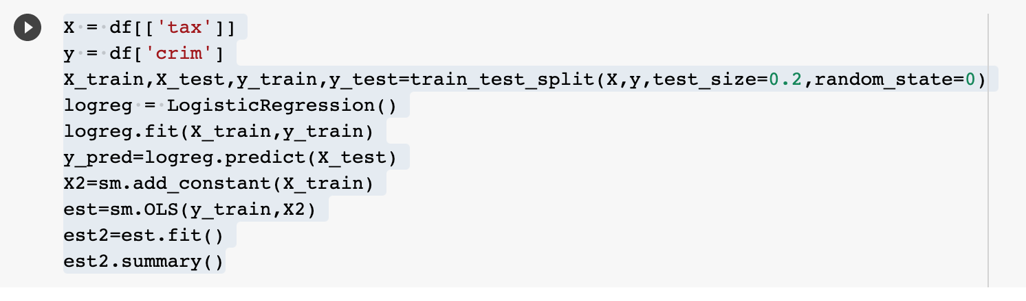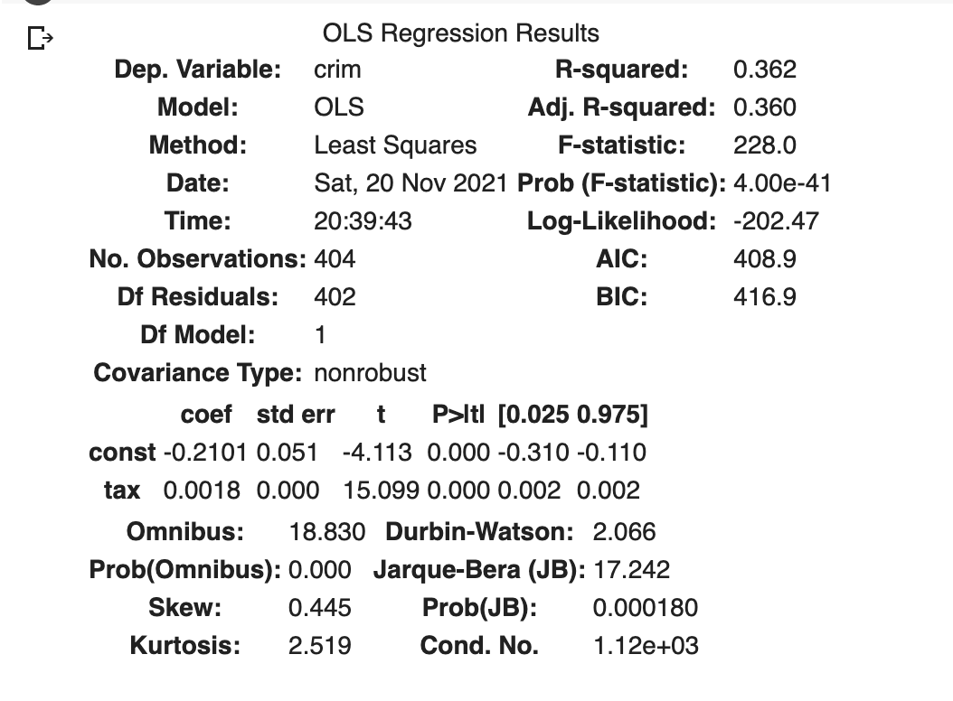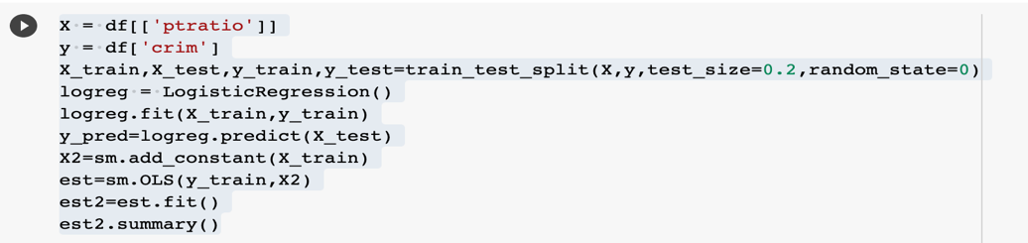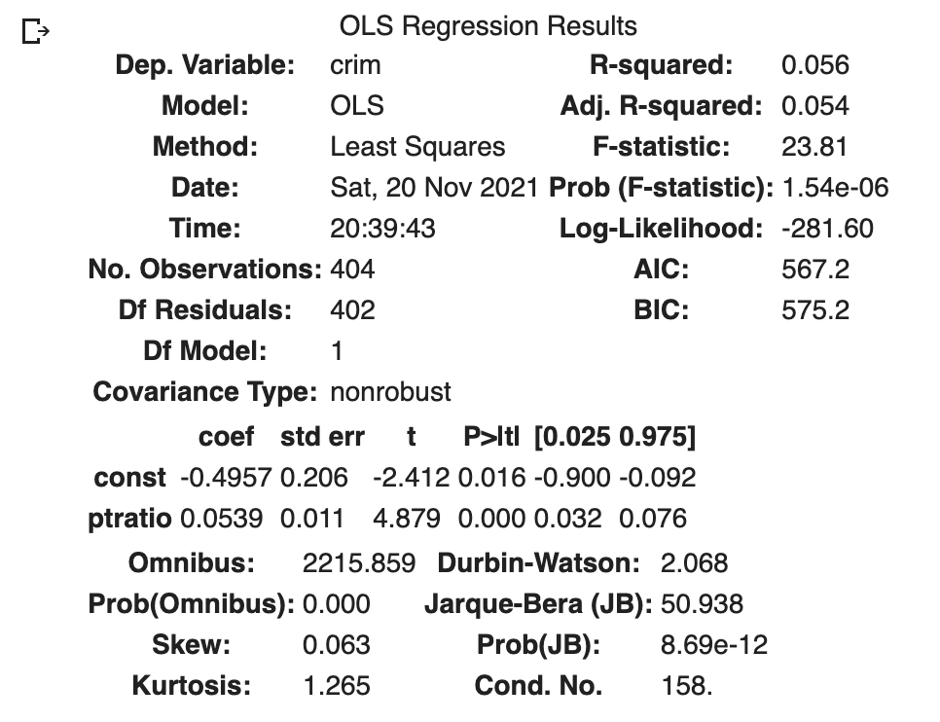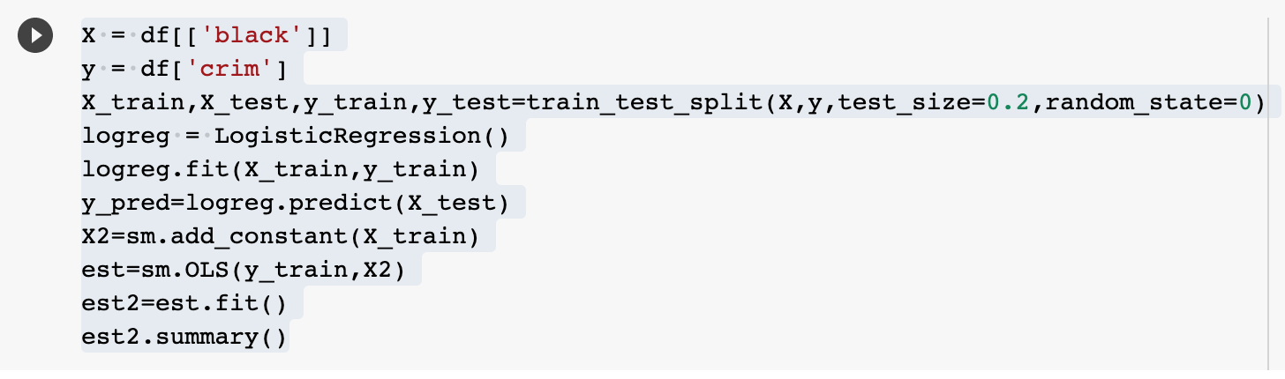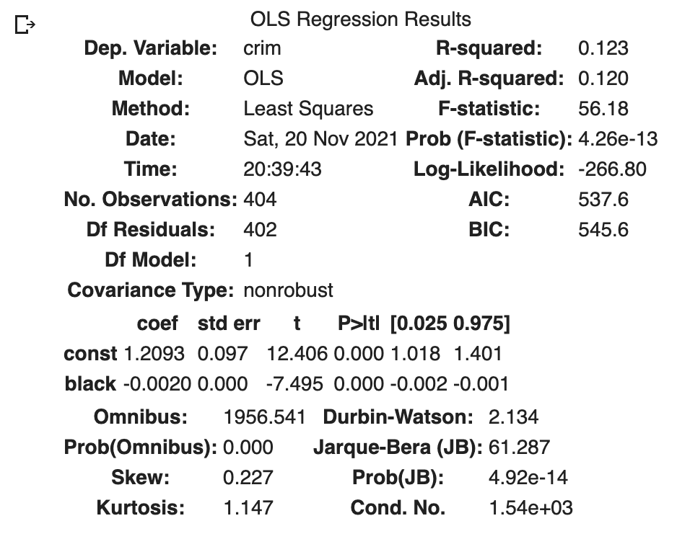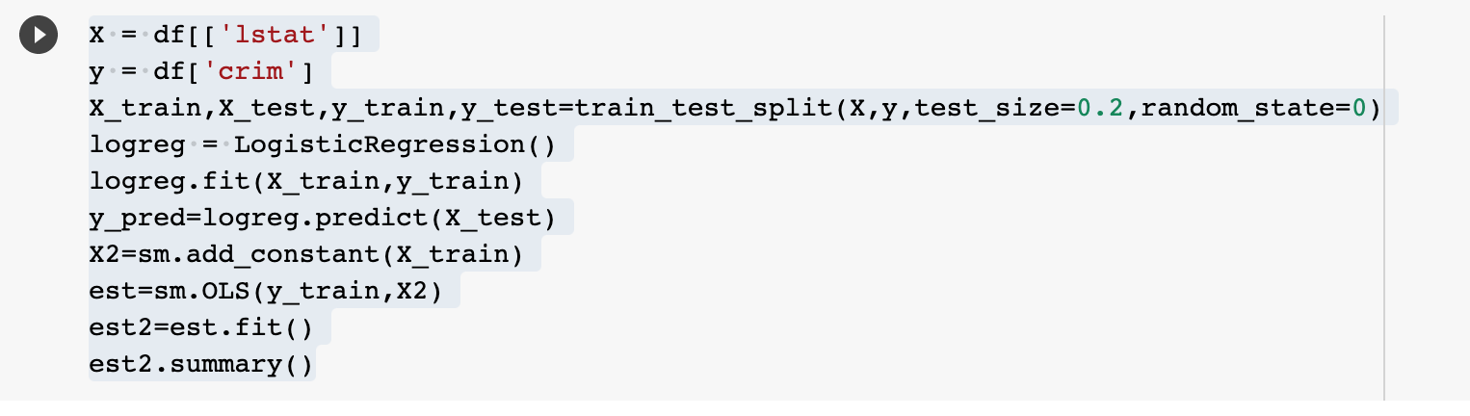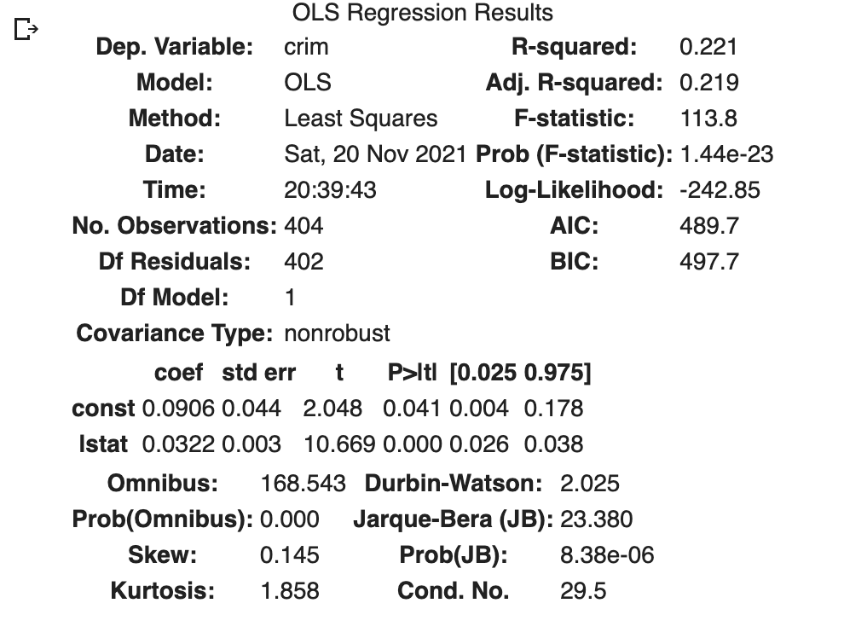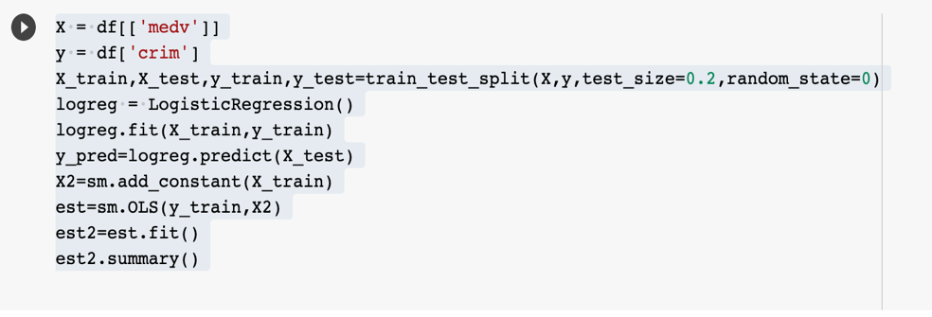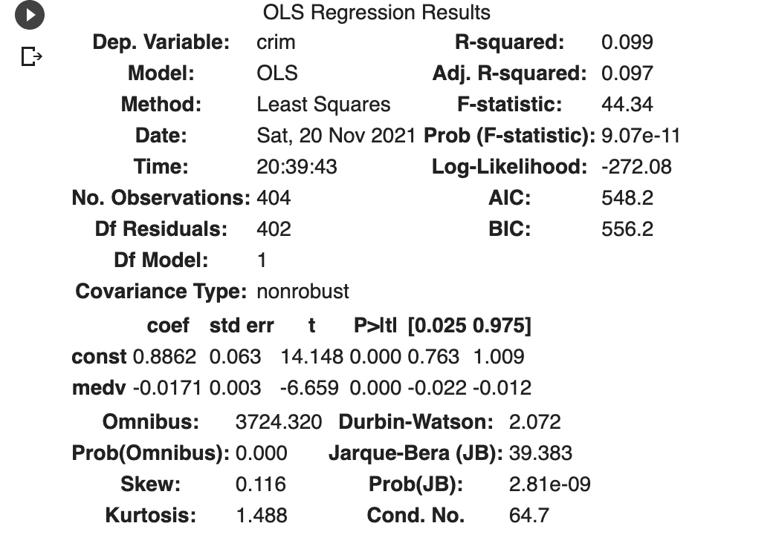

To find which predictors are significant, we have to test H0:β1=0. All predictors have a p-value less than 0.05 except “chas”, so we may conclude that there is a statistically significant association between each predictor and the response except for the “chas” predictor in this particular case.

1. Fit a multiple logistic model to predict the response using all of the predictors. Describe your results.  
   (i) Do any of the predictors appear to be statistically significant (set α = 0.05)? If so, which ones?

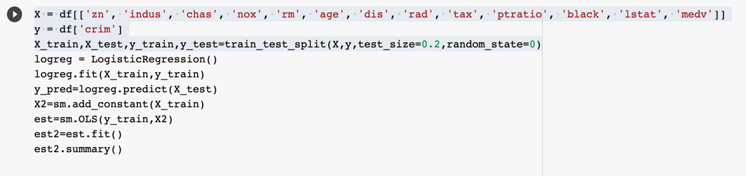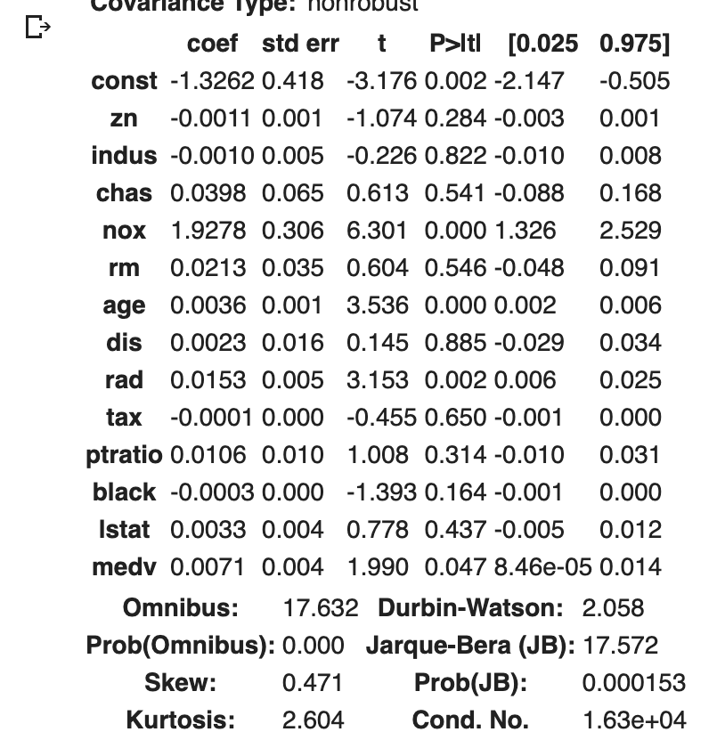

We may reject the null hypothesis for "nox", "age", “rad”, “black” and “medv”.

(ii) Predict whether a given suburb has a crime rate above or below the median for a  
suburb with:  
zn=18 indus=2.97 chas= 0 nox= 0.4 rm=6.575 age=63 dis=4.8  
rad=3 tax=238 ptratio=15.3 black=376.7 lstat=8.23 medv=45

Ans: The crime rate is below median for the suburb with the above values

(iii)Compute the confusion matrix, accuracy, balanced accuracy, FP, and FP rates for Threshold=0.5. Explain what the confusion matrix is telling you about the types of

mistakes made by logistic regression.

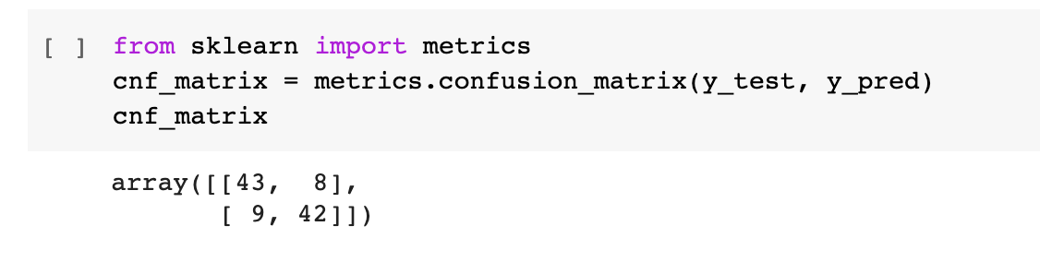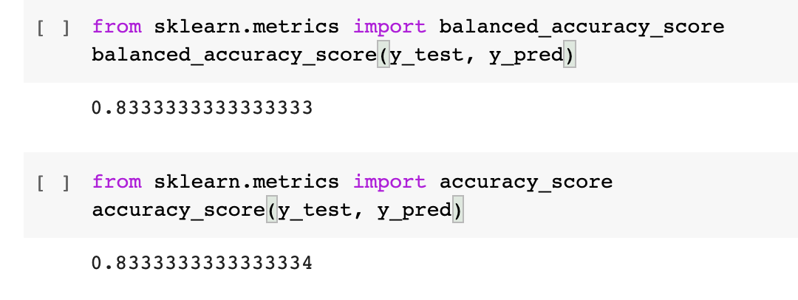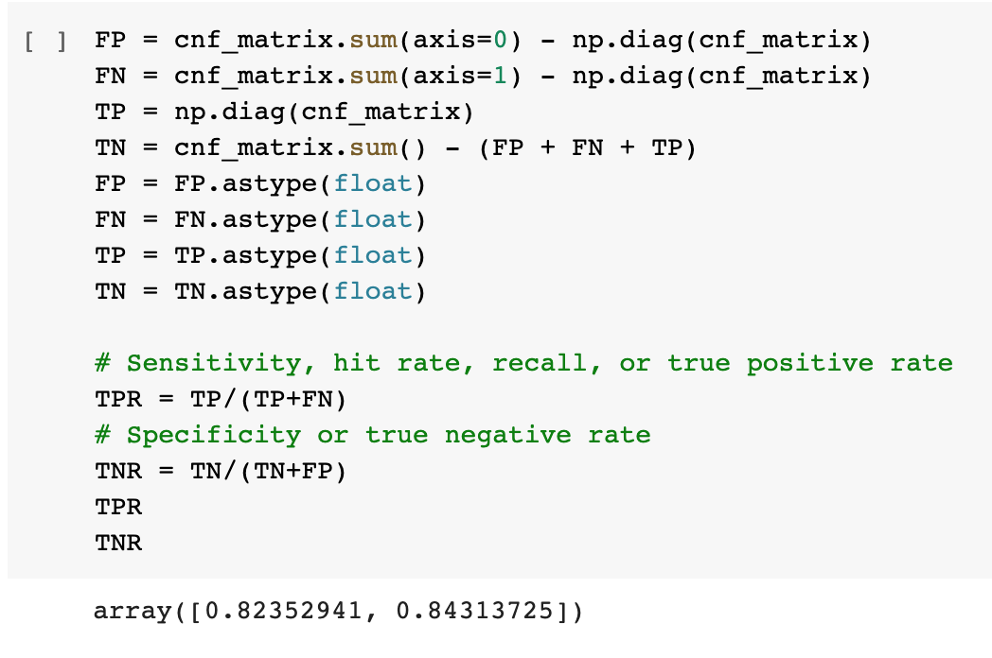

Confusion matrix says that the misclassification rate of the logistic regression is high.

(iv) Draw the ROC curve. What is the AUC?

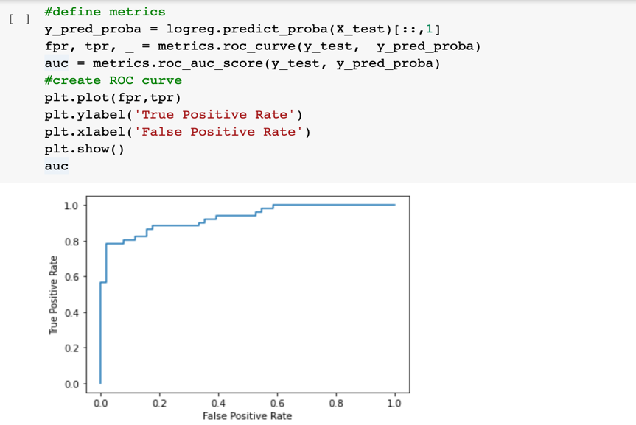

auc: 0.9284890426758939

(v) Determine the threshold for which (TP rate + (1-FP rate)) is maximal. Then, compute the confusion matrix, accuracy, balanced accuracy, FP, and FP rates for that threshold.

Ans: Threshold is 0.8

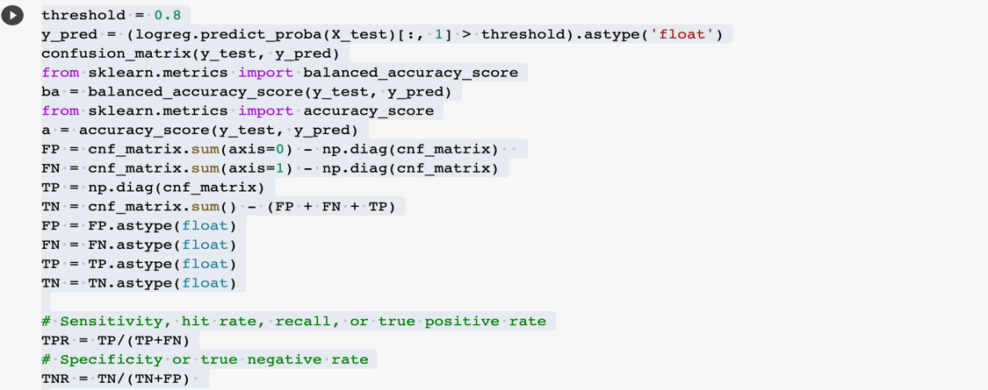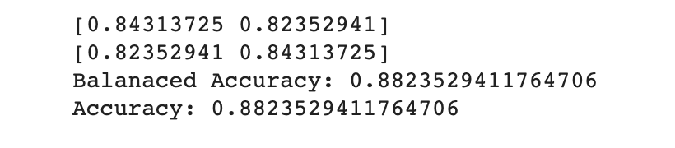

(vi) Determine the threshold for which the ROC curve has the minimum distance to the upper left corner (where TP rate=1 and FP rate=0). Note that this distance is√(1 −TP rate)2 + (FP rate)2. Then, compute the confusion matrix, accuracy, balanced accuracy, FP, and FP rates for that threshold.

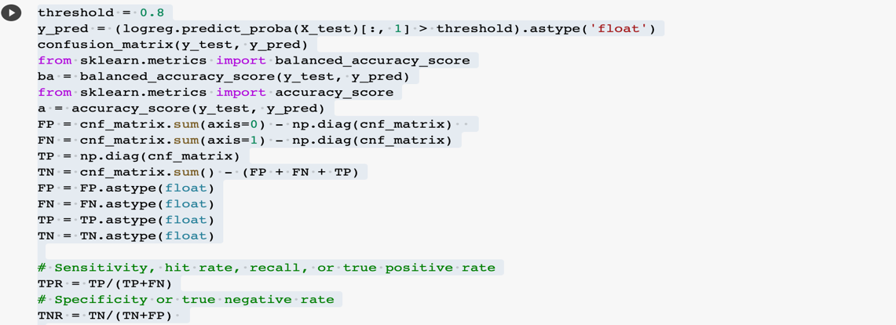

1. Which predictors matter most for predicting whether a given suburb has a crime rate above or below the median? (Find the first and the second most important variables)

Ans: “age” and “nox” are the two important predictors

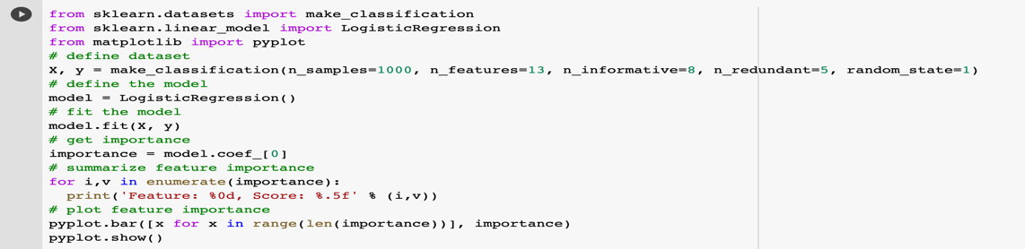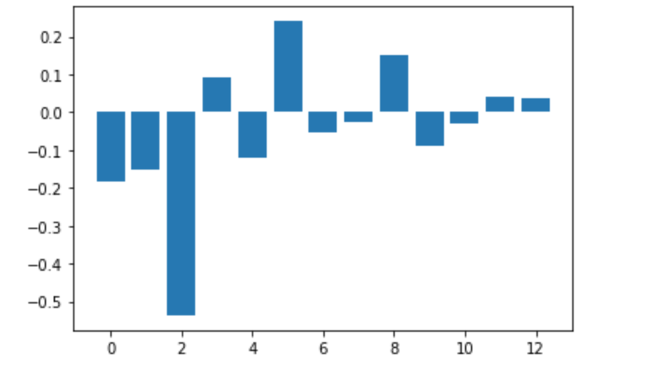

1. Fit a multiple logistic model to predict the response using the first two most  
   important variables in Part (c).  
   (i) Write out the model in equation form.

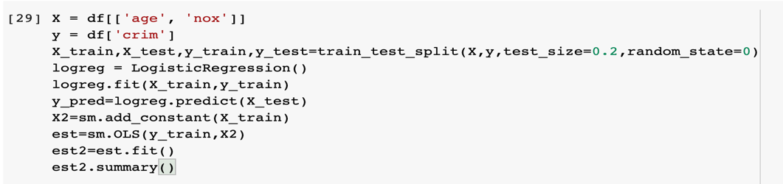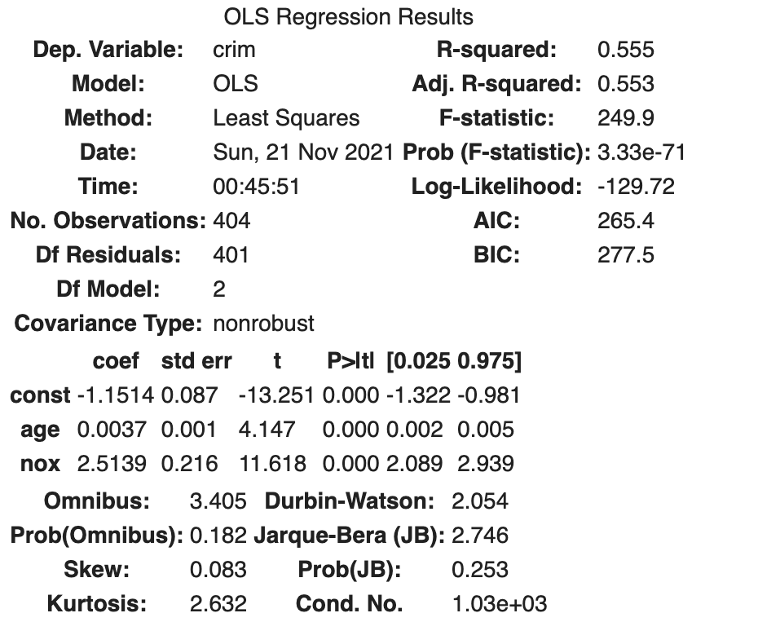

(ii) Draw the ROC curve. What is the AUC?

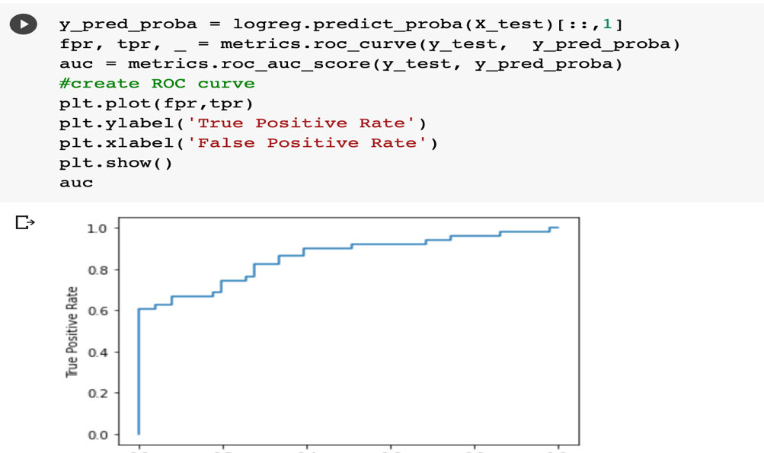

auc: 0.857362

(iii) Determine the threshold for which (TP rate + (1-FP rate)) is maximal. Then, compute the confusion matrix, accuracy, balanced accuracy, FP, and FP rates for that threshold.

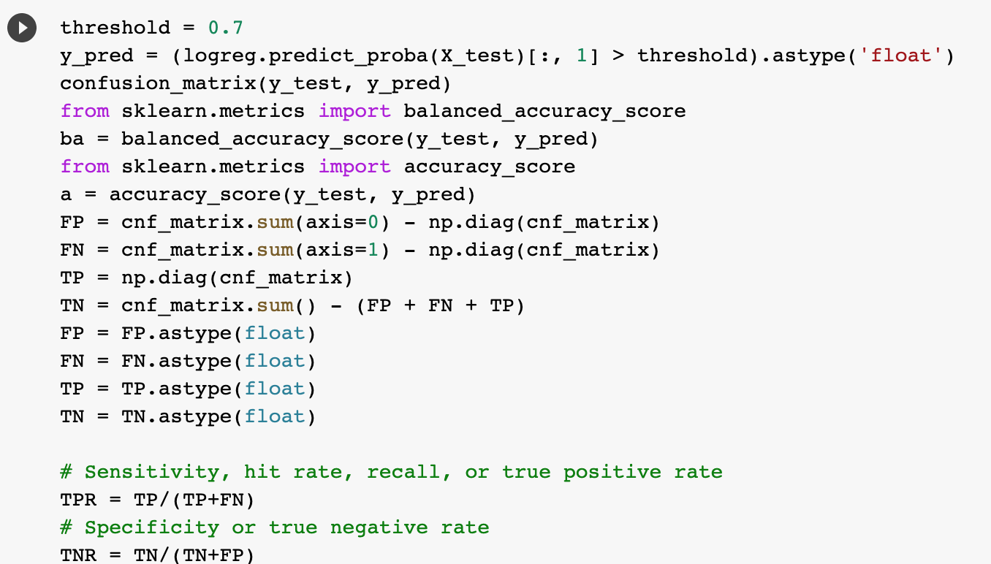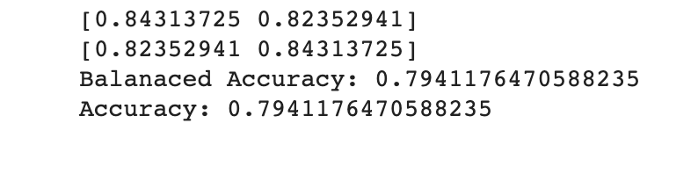

4. Suppose we produce ten bootstrapped samples from a data set containing  
red and green classes. We then apply a classification tree to each bootstrapped sample and, for a specific value of X, produce 10 estimates of P(Class is Red | X): 0.1,0.15,0.2,0.2,0.55,0.6,0.6,0.65,0.7, and 0.75.There are two common ways to combine these results together into a single class prediction. One is the majority vote approach. The second approach is to classify based on the average probability. In this example, what is the final classification under each of these two approaches?

Ans: Majority vote: 6 vs 4 => red

Average probability: P(Class is Red | X) = 4.5/10= 0.45

5. This problem involves the Carseats data set. We want to predict Sales using  
regression trees. Split the data set into a training set (75%) and a test set (25%)

1. Fit a regression tree to the training set. Plot the tree, and interpret the results.  
   What test MSE do you obtain?

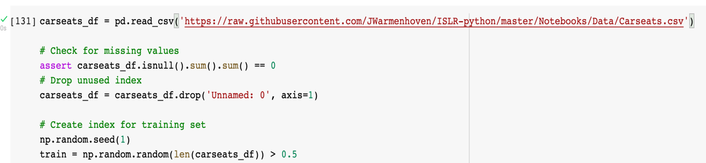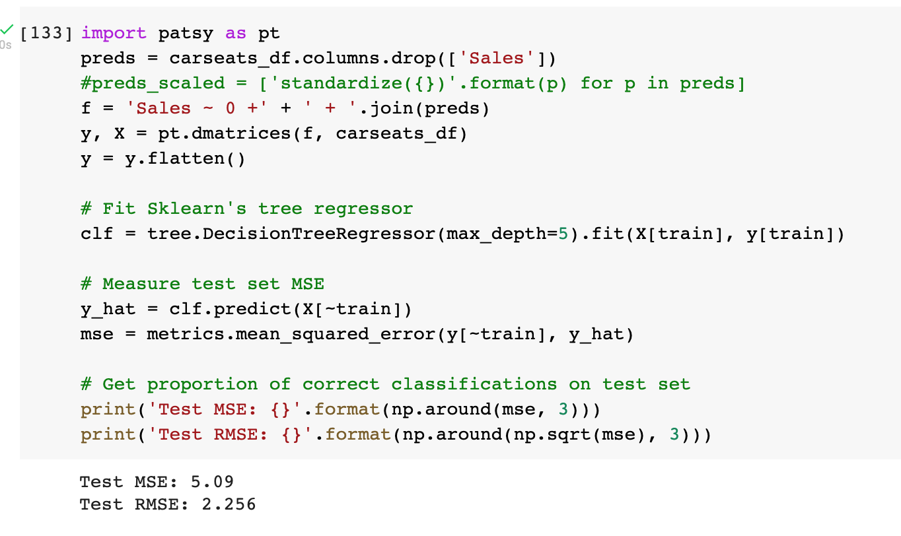

1. Use cross-validation in order to determine the optimal level of tree complexity.  
   Does pruning the tree improve the test MSE?

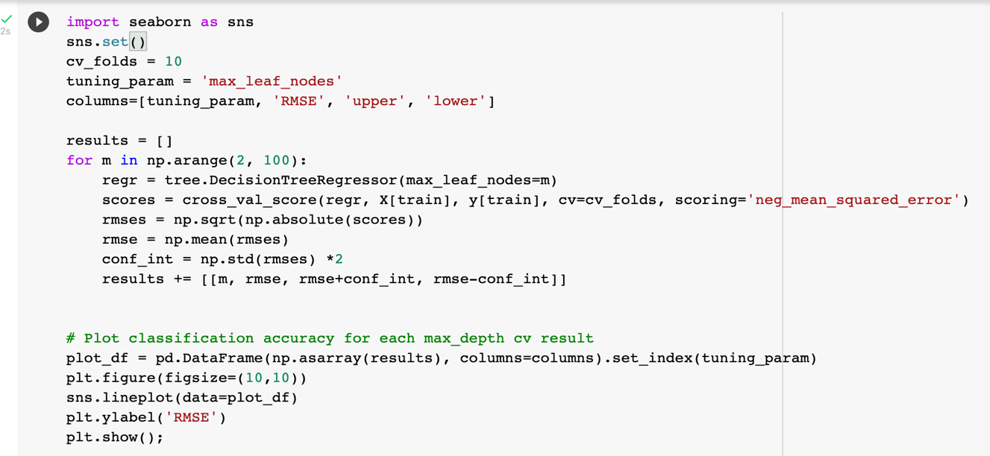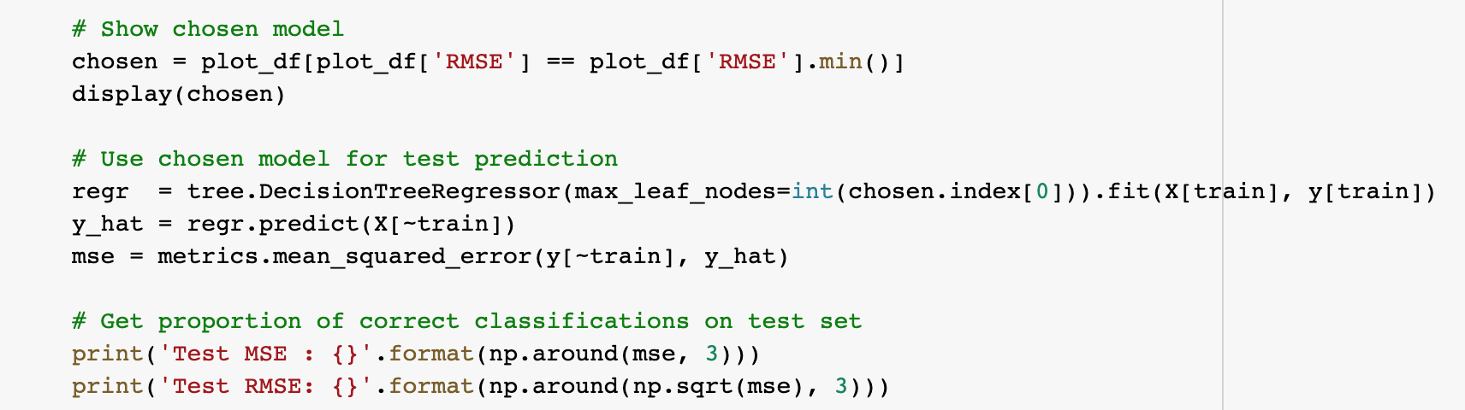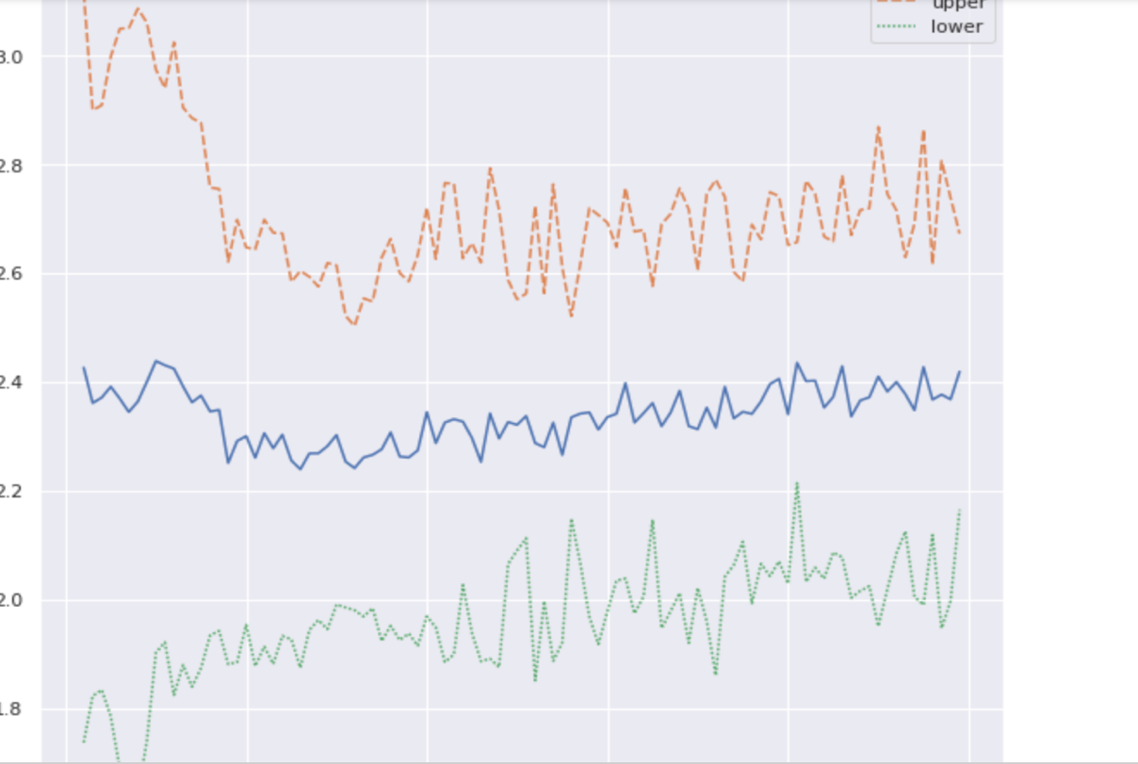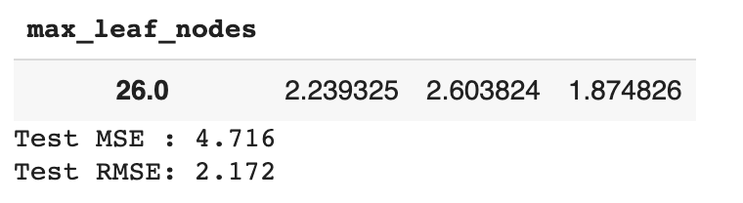

10-fold cross validation selects a pruned tree model that achieves test MSE of 4.524, an improvement on the unpruned model (5.066). Interestingly 100-fold, 5-fold and 2-fold CV were all unable to select an improvement on the unpruned model.

1. Use the bagging approach in order to analyze this data. What test MSE do  
   you obtain? Determine which variables are most important.

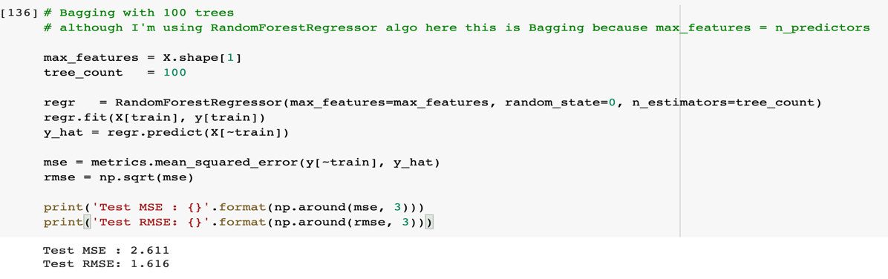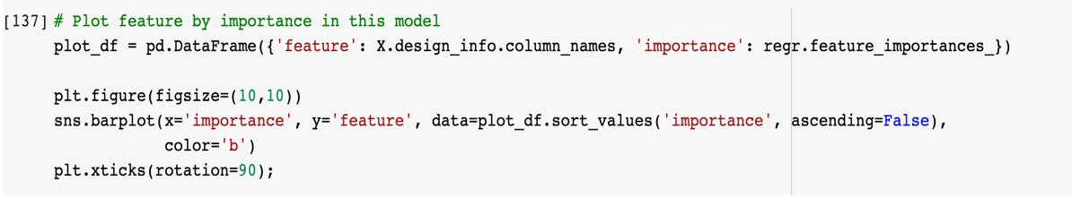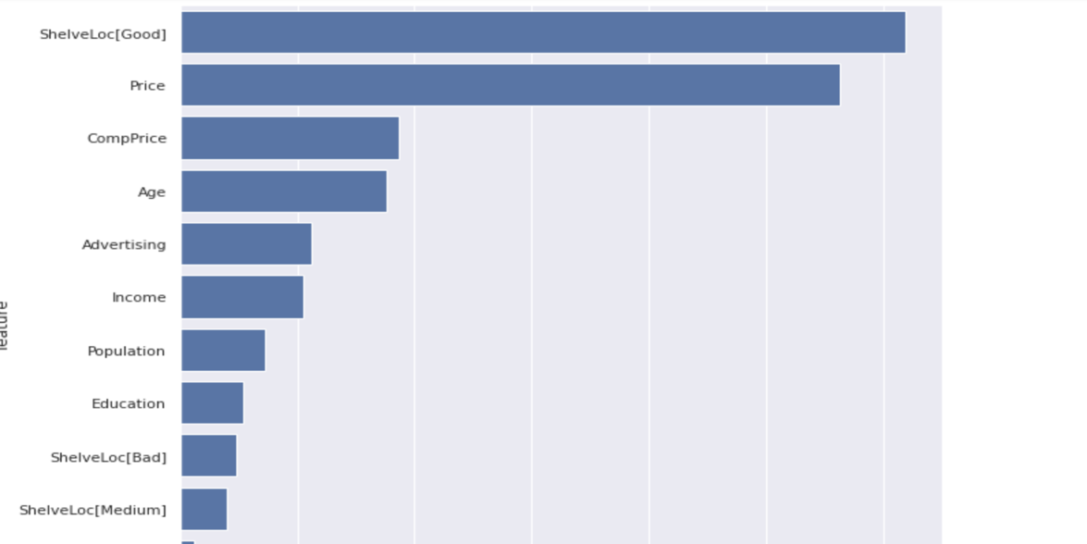

Bagging yields a significantly improved test MSE of 2.615 compared with 4.524 for the optimal pruned tree.

The bagging model indicates that instore Shelve Location (Good) and Price of the carseat are the most significant features affecting Sales revenue.

1. Use random forests to analyze this data. What test MSE do you obtain?  
   Determine which variables are most important. Describe the effect of the number of variables considered at each split on the error rate obtained.

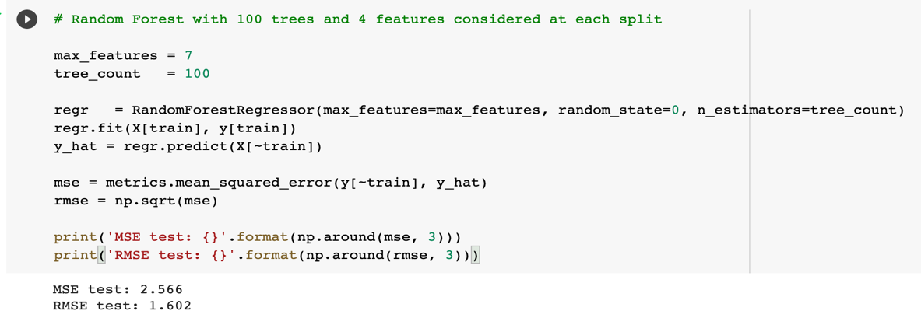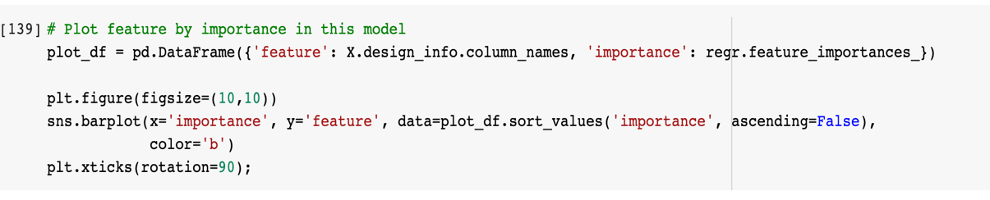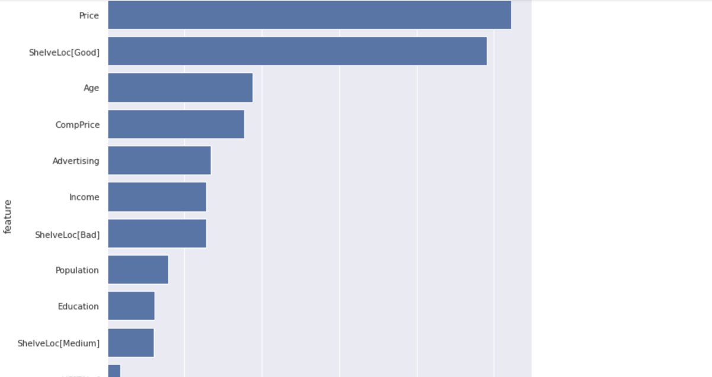

Random forest with 7 predictors at each split yields a test MSE 2.544 similar to bagging (2.615). A similar feature importance is ascribed.

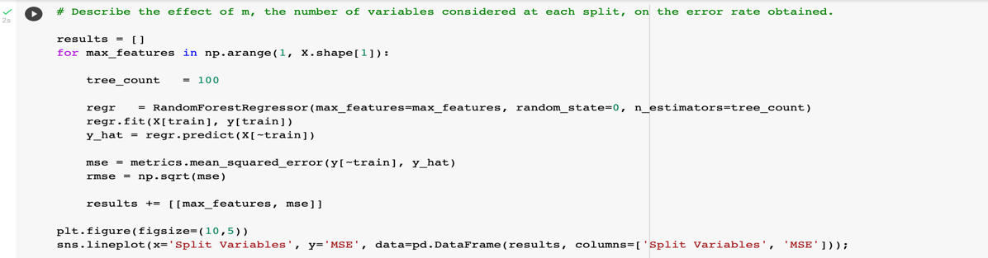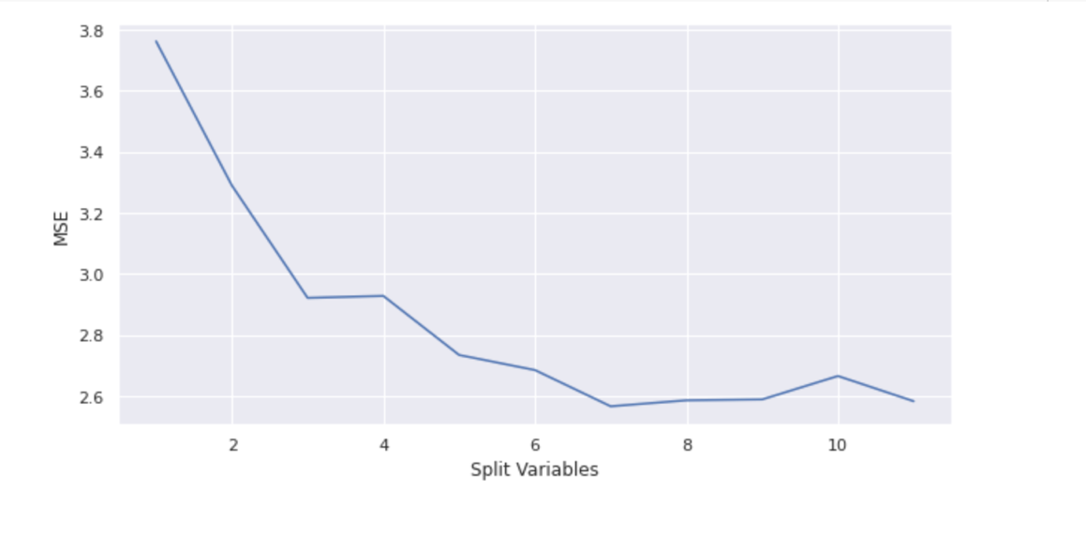

6. This question uses the Caravan data set. Create a training set consisting of  
the first 1,000 observations, and a test set consisting of the remaining observations.

1. Fit a boosting model to the training set with Purchase as the response and  
   the other variables as predictors. Use 1,000 trees, and a shrinkage value of 0.01. Which predictors appear to be the most important?

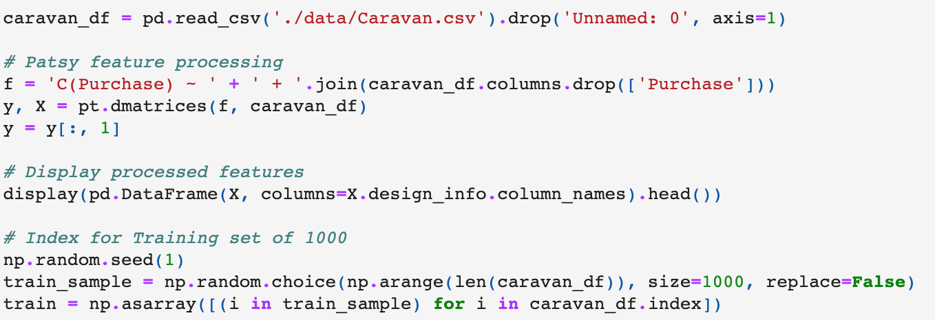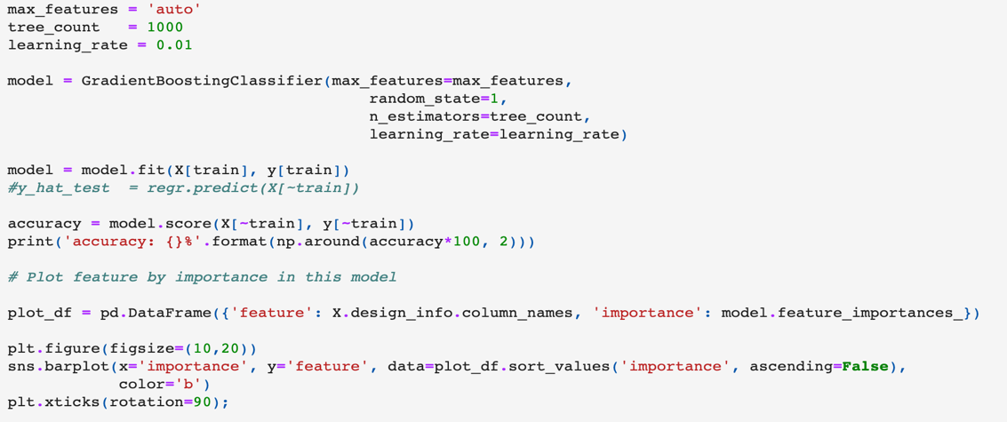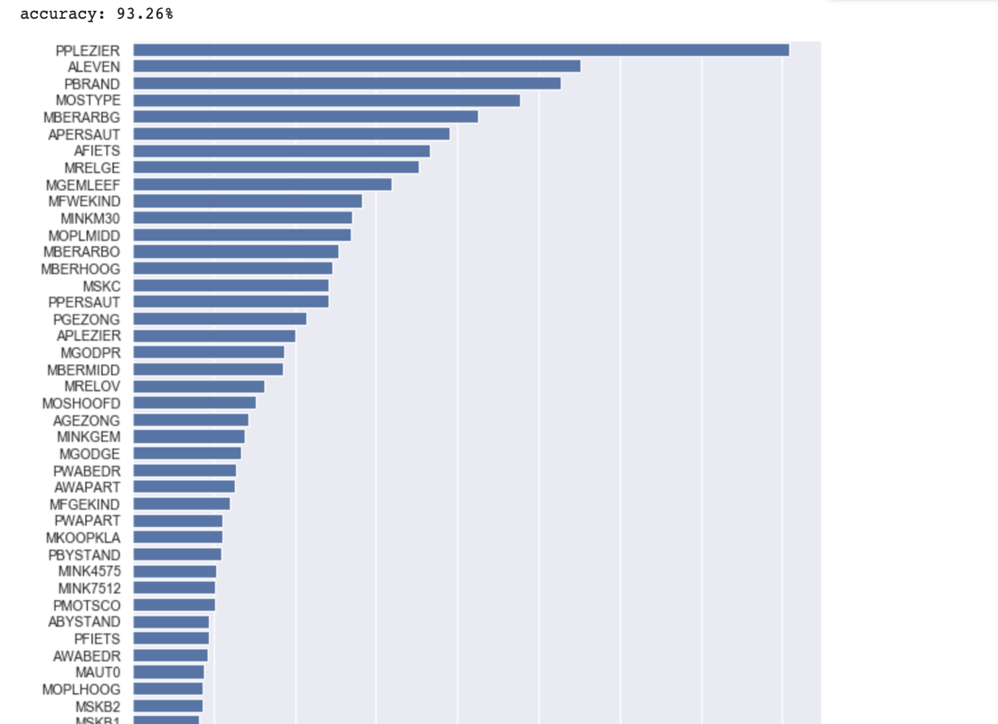

Here we use boosting to predict if someone purchases caravan insurance, a classification problem. The boosting model yields a test set prediction accuracy of 93.2%.

The model suggests that the ten most important predictors are:

* PPLEIZER: Contribution boat policies
* ALEVAN: Number of life insurances
* PBRAND: Contribution fire policies
* MOSTYPE: Customer Subtype; see L0
* MBERARBG: Skilled labourers
* APERSAUT: Number of car policies
* AFIETS: Number of bicycle policies
* MRELGE: Married
* MGEMLEEF: Avg age
* MFWEKIND: Household with children

Broadly these predictors indicate whether customer has other insurance policies, and their level of family commitment e.g. married, with children.

We can't tell the direction in which these predictors are related with response

1. Use the boosting model to predict the response on the test data. Predict that  
   a person will make a purchase if the estimated probability of purchase is greater than 20%. Form a confusion matrix. What fraction of the people predicted to make a purchase do in fact make one? How does this compare with the results obtained from applying logistic regression to this data set?

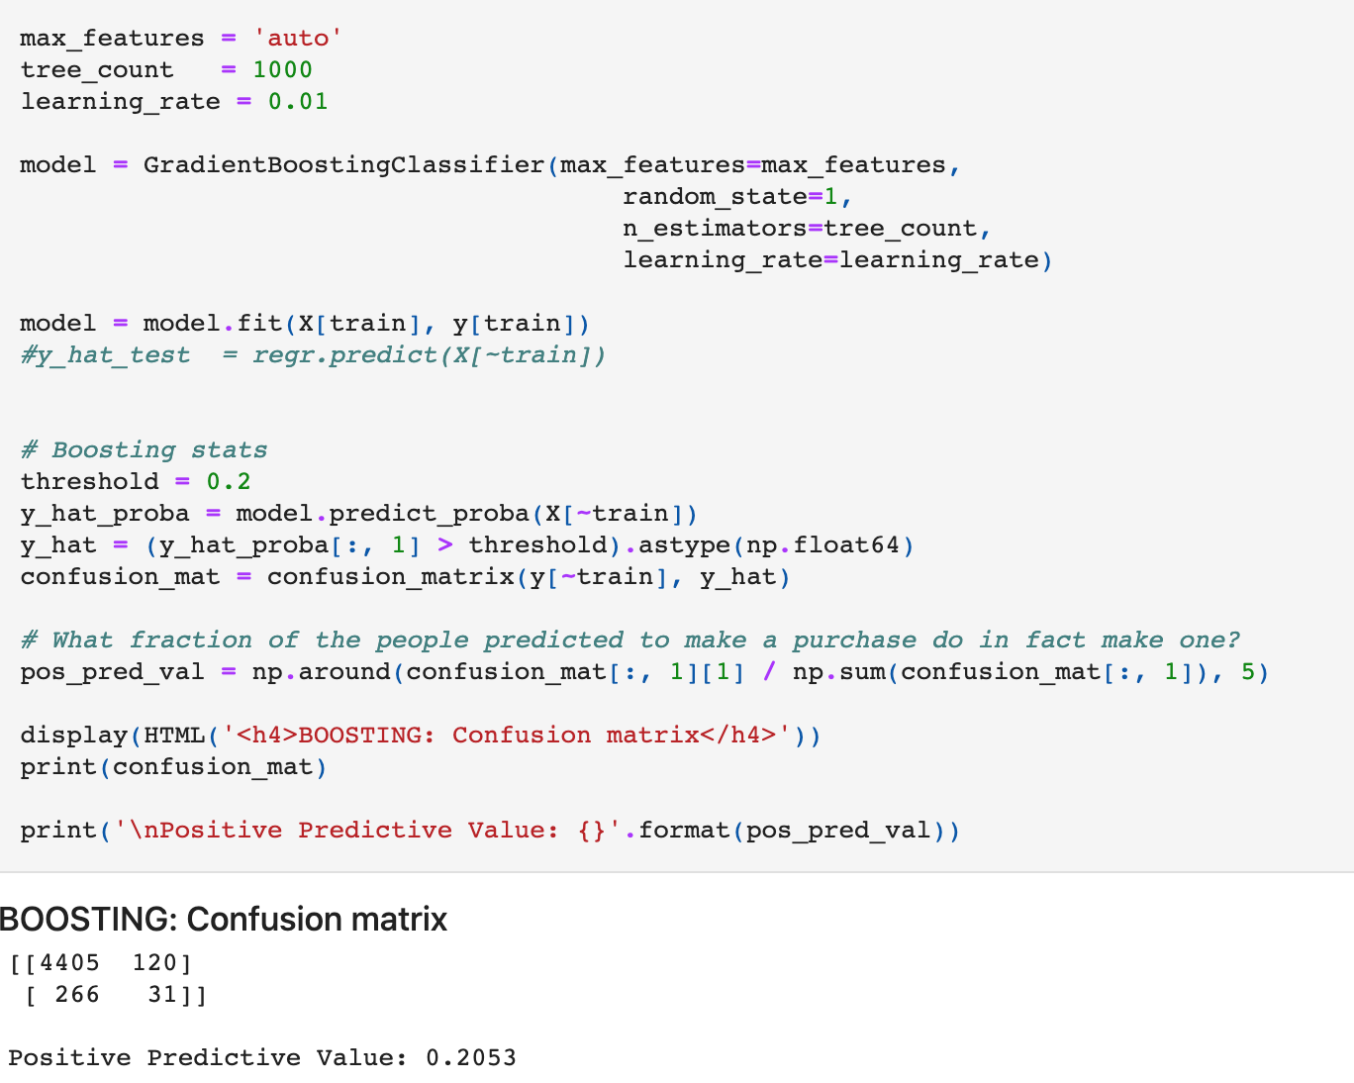

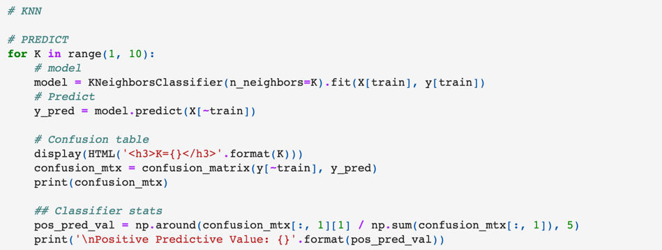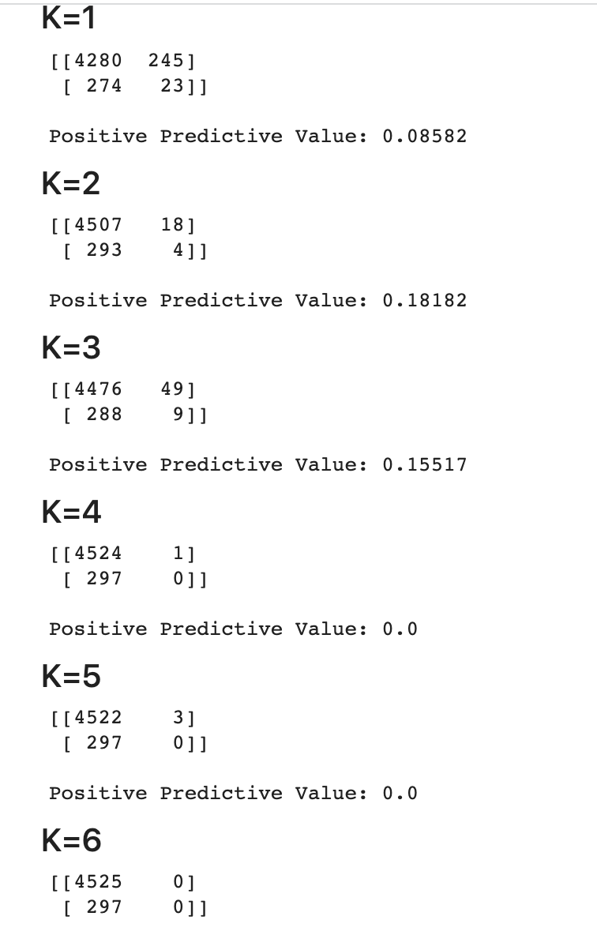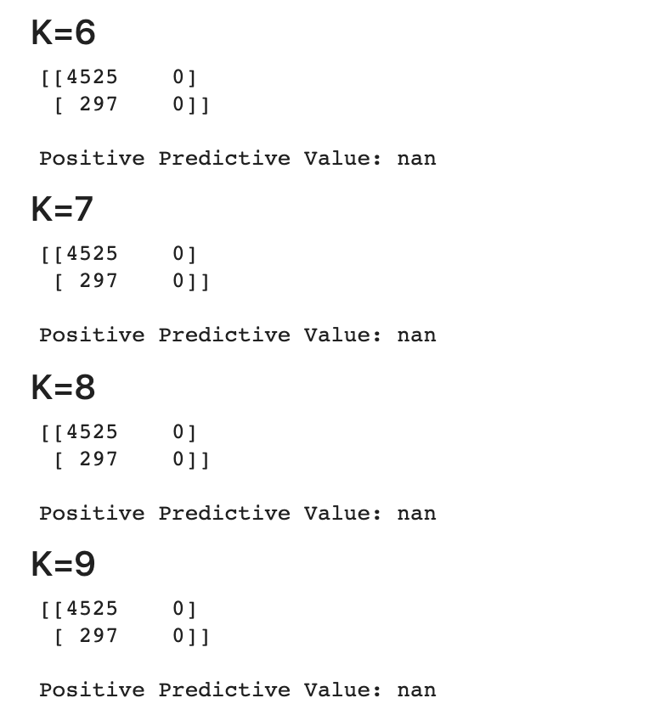

KNN performs best when k=2 achieving a Positive Predictive Value of 0.182, which is slightly worse but not dissimilar to the boosting result (0.205). The boosting model also excels in achieving roughly 8 times more True Positive predictions, so we would certainly choose the boosting model in this case.

It is worth noting that the dataset in this setting is highly dimensional with over 80 predictors, so the effectiveness of KNN is likely hindered by the curse of dimensionality